Caplin´s visit to the Hague
In May 2018 (7-9, Nieuwe Badkapel, Scheveningen) we had the pleasure of welcoming William Caplin (McGill University) to the Hague for a series of lectures and workshops aimed at students, teachers and members of the Dutch Flemish Society for Music Theory. The general topic of Caplin´s visit was cadence and thematic closure in nineteenth-century music, with a brief excursion to the Baroque period in the final session (cadences in the fugues of Bach´s Das wohltemperierte Klavier).
Over the course of his workshops, Caplin offered a number of thought-provoking ideas on nineteenth-century music, which invited a lively discussion from the audience. The most important topics raised were: 1) a more extensive use of chromaticism and dissonance; 2) a greater emphasis on root-position harmonies in determining function and cadential closure; 3) a more uniform understanding of harmonic rhythm and harmonic density; 4) a lack of cadential closure for thematic units; and 5) an ambiguity between penultimate and ultimate dominants at potential cadence points.
I would like to illustrate this last point with two different passages from the first movement of Schubert´s Piano Sonata in A major, D. 959. Both these examples were discussed by Caplin. The examples (with Caplin´s annotations) are offered below.
Example 1: Schubert, Sonata in A major, D.959, I, mm.55-82
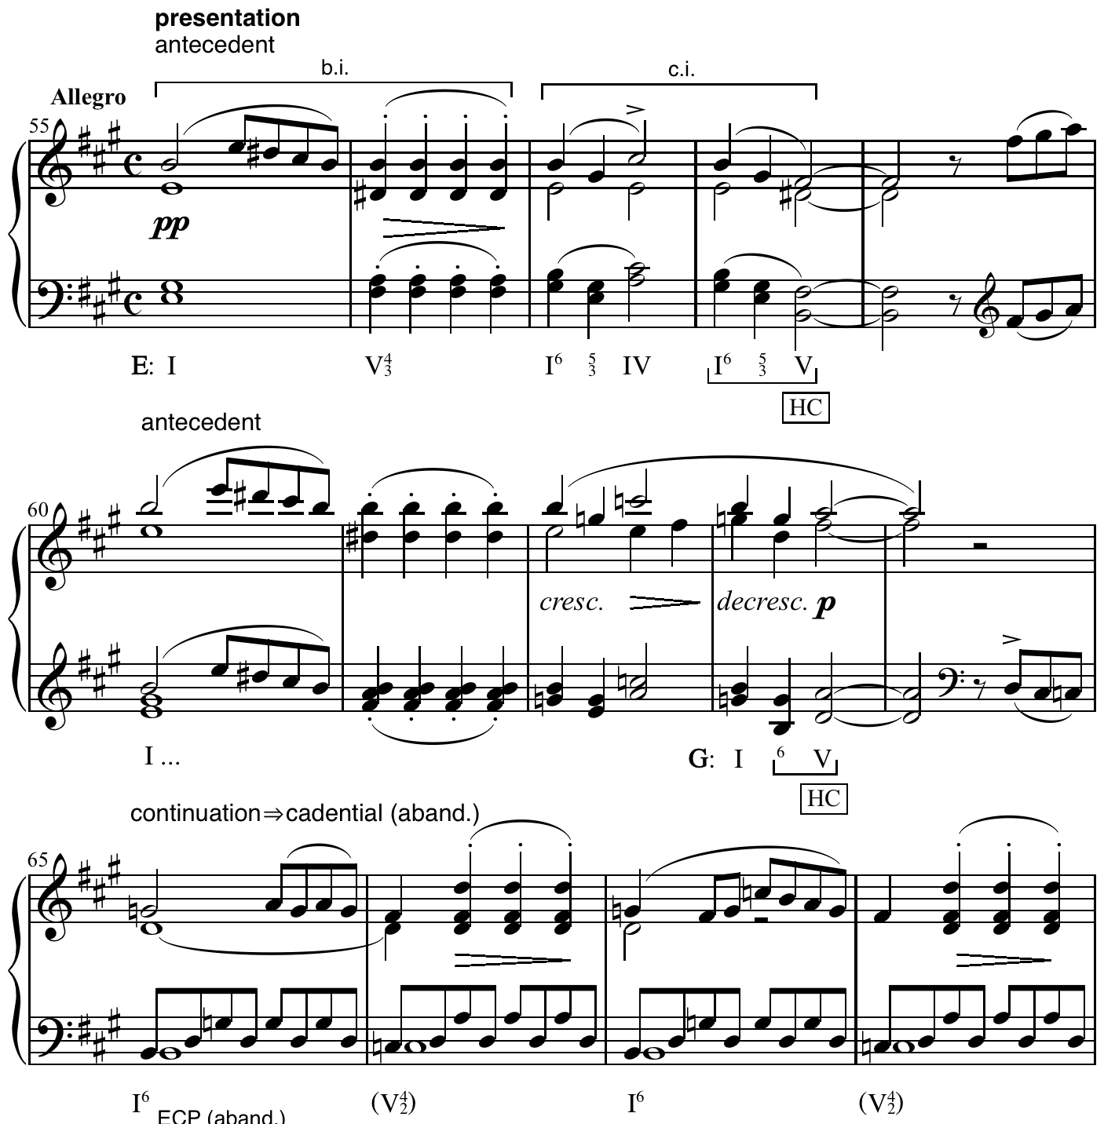

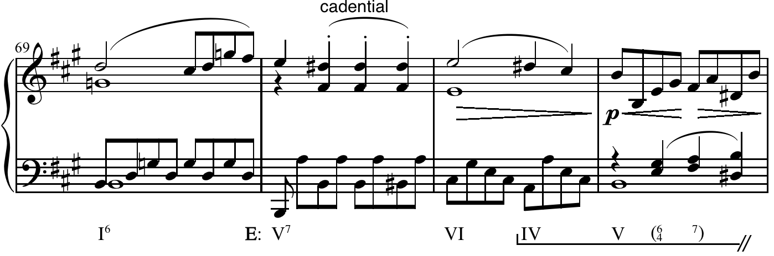
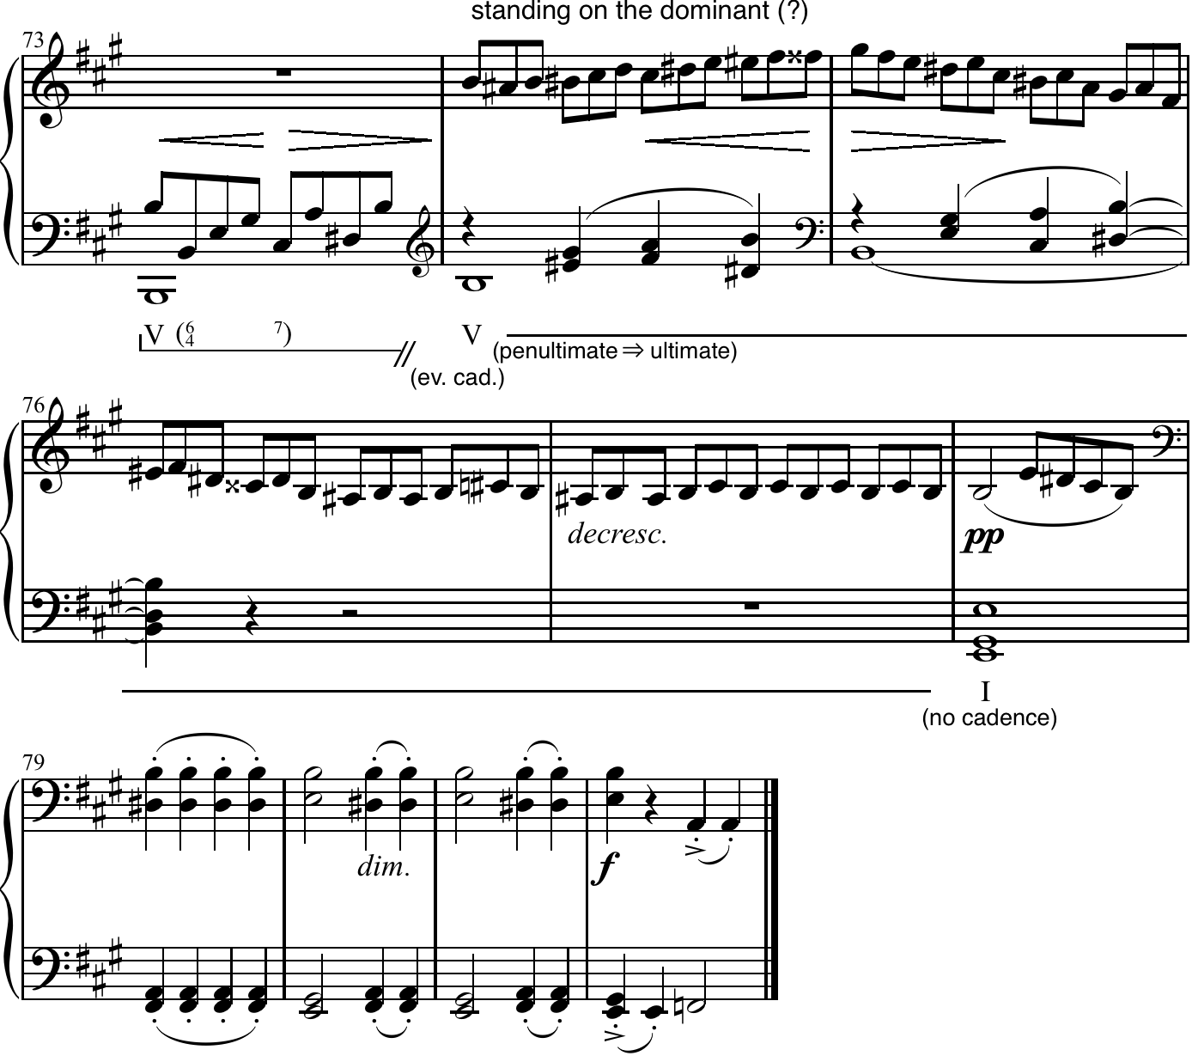

Example 2: Schubert, Sonata in A major, D.959, I, mm 1-26
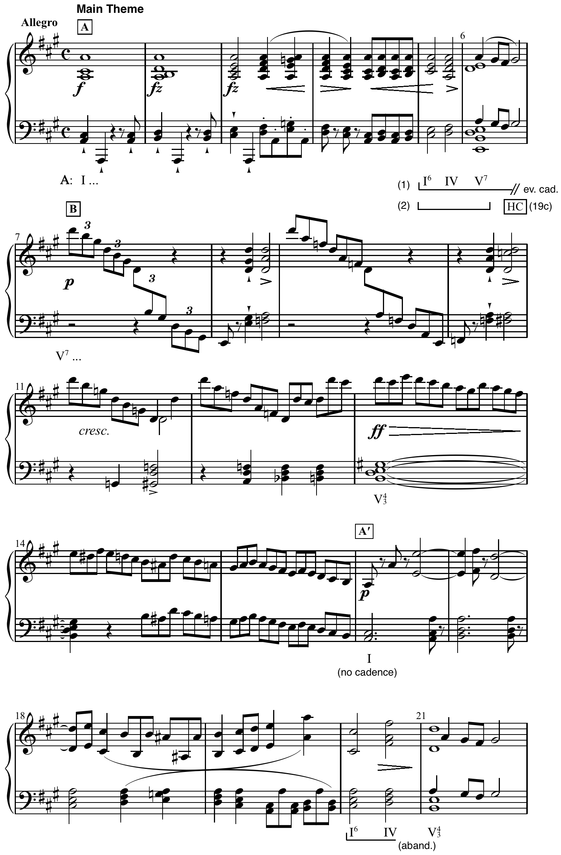
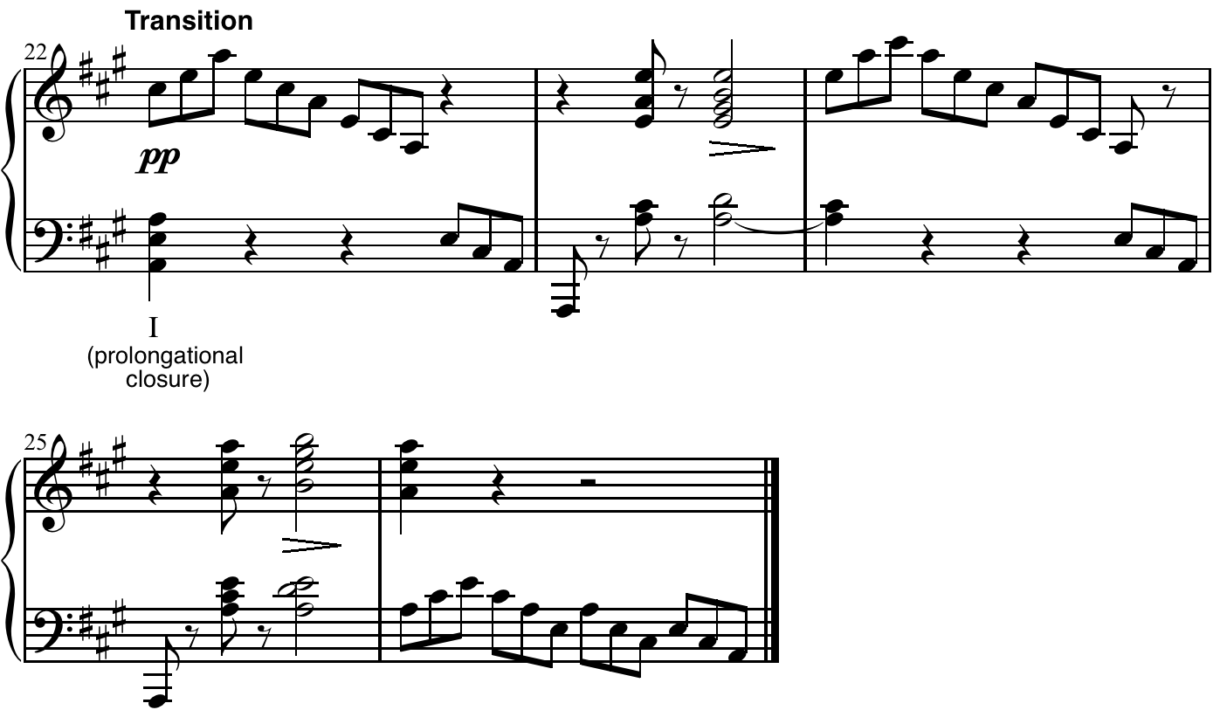
In the first example we can see that from mm.74 onwards, the phrase stands on the dominant (after two attempts in which the cadence is evaded). This standing on the dominant and the fact that in Caplin´s interpretation there is no cadence in m.78 implies that in his opinion, we could perceive the penultimate dominant in m.74 as the ultimate dominant.
In the second example, the situation is more ambiguous: Caplin offers two interpretations of the cadence at m.6. His first interpretation (1) is based on his concept of classical cadence, in which reaching a V7 would not be considered as the goal or ending point of a cadence. Therefore, that cadence in m. 6, would not be perceive as a half cadence, but more as an evaded cadence because any of the voices resolve in the following measure. The second interpretation (2), the interpretation that Caplin pleads for, is the romantic half cadence interpretation, in which the penultimate dominant (the dominant which should resolve into the tonic) becomes the ultimate dominant, creating a half cadence. Caplin in this case, does not consider m. 16 as a PAC, in which the dominant would resolve to the tonic.
However, from m. 7 to m.15 we could also say that there is an extension of the previous dominant seventh chord, in which, after the chromatically ascending bass line, the acceleration of the harmonic rhythm and the crescendo in the dynamics, the dominant seventh chord is repeated in mm. 13 (now in 4/3 position and played ff). This repetition of the dominant in mm. 13 makes it easier for the listener to hear its resolution in mm.16. In fact, we could argue that the listener could hear the whole passage as a long extension of the dominant (from m. 6), which finally resolves in m.16 into a tonic.
We could say that elements such as the length of the standing on the dominant, and the use of the seventh in the dominant chord, are factors that could change the perception of what sort of cadence the listener perceives and what plays a role in determining which sort of cadence we actually hear. Furthermore, it is worth mentioning how a specific musical passage can transform our perception in relation to the previous and following musical events.
With this short example I tried to show how many different interpretations were discussed among students, teachers and our guest during the sessions, creating a wonderful interaction between all of us.
All in all, the study days with William Caplin created a productive and collegial atmosphere, with inspiring sessions, lively discussion and thought-provoking ideas.

The extensive use of dissonance refers to a cadence in which the V7 is reached inmediatly, instead the V, more common in the classical period. The extensive use of chromaticism refers to the fact that from the moment that we reach a cadence, in many cases, instead of finding an expected I6/4 before V7, the V7 is approached by a secondary dominant, creating a chromatic line in the bass, for instance.
We could understand “uniform” used by Caplin as a synonym for “regular”

